Grade 7 Accelerated · Unit 3 · Lessons 6–7  Evaluating and Equivalent Expressions  Independent Set 3.06 | Name______________________  Date______________________  Period____________________

Six questions, on your own, in silence. Show the step that does the work.
1. Find the value. 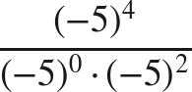

2. Find the value. 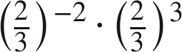

3. Write as a power of 2. 

4. Write as a power of 3. 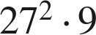

5. Are 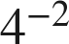 and 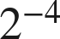 equivalent? Show why.

6. Find the value. 